**GearShare**

“Bringing Like-Minded People Together Outdoors”

|  |
| --- |
| GearShare Business Plan | TK Coody, Jackie Carroll, Davis Kigin, Connor Guerrieri |

Table of Contents

Executive Summary 3

Opportunity 3

GearShare Concept 3

Marketing Strategy 3

Competitive Advantage 3

Management 3

Finances 3

Funding 3

Company Overview 4

Product or Service Plan 4

Future Service Plans 5

Product/Service Strategy 5

Value Proposition 6

Proprietary Rights 6

Stage of Development 6

Market and Industry Analysis 7

Overall Market 7

Addressable Market 7

Industry Analysis 8

Competition 8

Opportunity 9

Marketing Plan 10

Member Research 10

Member Profile 10

Buying Decisions 10

Member Behavior 11

Channel Strategy 11

Positioning 11

Brand Identity 12

Digital Strategy & Communication Strategy 12

Sales Strategy 12

Pricing Strategy 13

Revenue Model 13

Operations Plan 15

Operations Strategy 16

Scope of Operations 16

Research, Development, and Engineering 16

Key Milestones 17

Management Plan 17

Risks 18

Financial Plan 20

Key Drivers 21

Required Startup Funds 21

Funding Plan 21

Appendix 23

# ****Executive Summary****

## Opportunity

Interest in outdoor recreation is on the rise and with advent of social media people are always interested in group activities. The expense of owning equipment and not using it or purchasing new gear is stressful, and so is finding someone to accompany you on your next adventure. GearShare looks to bridge this gap by bringing likeminded outdoors-interested people together through events, outdoor meet ups, and providing a peer-to-peer gear rental system.

## GearShare Concept

GearShare will connect with members and users through a website and smart phone application. These will be the main form of communication for GearShare events and also how we connect gear lenders and renters. There will be a profile for each person with their favorite outdoor activities and places to share adventure stories. This will also support our peer accountability system where people can be rated on their service when renting. Previous social networking and gear sharing websites have grown to 30,000 members in 3 years.

## Marketing Strategy

GearShare hopes consumers will view the service as another form of social media. The Customer will see GearShare as a place to meet new people, share outdoor stories and current events, while also planning your next outdoor excursion. Possible members will be tech-savy outdoor minded individuals. We will reach this target market through web and social media advertisements, posting of flyers at high traffic areas, coffee shops and rec centers.

## Competitive Advantage

GearShare’s competitive advantage will be reaching out to new people to outdoor sports. We will attract and bring together people in a non-judgemental inclusive space to help people become involved in outdoor sports. This will help grow our membership and event attendance, eventually helping GearShare’s website become a major social media hub for outdoor activities.

## Management

Advised by a board of directors with knowledge in entrepreneurship and technology the gear share team will be made up of the four founders who bring a diverse knowledge of computer science, engineering, finance, marketing, and management that will help grow GearShare.

## Finances

At the end of the third year of operations GearShare will be nearing 8,000 members and have total income of $800,460 and a net income of $500,897. We will have a total of $352,887 in free cash assets to begin expanding to other cities and attracting more members.

## Funding

GearShare has a very simple funding plan, with the founders contributing the majority of the capital. Owner’s investments will total $40,000 each with a 20% ownership. With minimal startup costs we look for an initial investment of $35,000 from a private investor for a 20% ownership. We will also be seeking a $35,000 small business bank loan to cover initial startup costs and operating costs.

# Company Overview

GearShare is a web-centeric company that provides newcomers to any outdoor activity lower costs to pursue any interests and the ability to meet new people while developing outdoor skills. GearShare will incorporate as an LLC and will be headquartered in Boulder, CO.

Mission Statement: GearShare strives to help everyone begin participating in the outdoor experience they’ve always wanted with lower costs and a friendly, engaging community.

Objectives: First and foremost, we hope to provide our members with quick, immediate access to outdoor events and gear at a fraction of standard costs via our website and smart phone app. We will also enable equipment posters to earn additional income streams from their unused gear and from hosting events or assisting with them. When a member uses GearShare, they gain access to a community designed around helping them engage in the wonderful outdoors, gear to help get them started, and events catered to their needs, all at a fraction of industry standard costs.

# Product or Service Plan

GearShare’s core mission will be to sponsor and develop outdoor events that provide an inclusive community for new outdoors enthusiasts. This will be done by providing a membership opportunity and using a website and companion phone app to provide a space for members to meet and communicate. GearShare will help facilitate education and learning opportunities to people interested in taking up a new outdoor activity. The events will be both for members and walk ups that will pay a flat fee.

GearShare Community & Website

The GearShare website will be accessible by both members and non-members. This service will be the main form of communication to members about events and also the virtual location where items can be posted and exchanged. Members will be able to have unlimited posting, preferred access to events, and earn points towards a rewards system. The website will have profiles created by each member, that allow them to post gear and individual meet ups.



Figure 1: GearShare Community and Website Features and Benefits

GearShare Peer-to-Peer Rental Services

The second focus area of GearShare will be to provide recommendations for equipment to new members. This will be selling new equipment from providers but also maintaining a peer-to-peer gear rental option. This will allow people just entering the activity of their choice to have a cost effective option instead of having to pay the full prices of new outdoor gear initially.

GearShare Events

 GearShare events will be centered around providing a space for novice outdoor interested people to develop skills and meet new people. GearShare will be holding two events a month during the summer months that will each have a different theme. At these events GearShare will provide food and places to sit and mingle, but beverages will be bought separately. These events will be a $15.00 dollar flat fee that includes food and the educational event.

Figure 2: GearShare Rental Services Features and Benefits

GearShare Onsite Advertising

GearShare will be looking to market its growing online outdoor community to potential retailers. GearShare will provide space for retailers to advertise with online banners so that they can reach our captive outdoor inclined audience. GearShare will also seek corporate sponsors to provide demo gear that our event attendants can try and become interested in.

## Future Service Plans

GearShare will provide space for ski rental stores, Christy Sport, to post items on GearShare’s website. Eventually expanding GearShare to own and maintain its own equipment which can be rented and sold on the website. This will allow members who rented gear they liked to have an easy way to transition into owning their own gear. To help facilitate the development of the GearShare community, the implementation of a reward system for frequent renters/sellers and purchasers would lead to member loyalty. Finally, while developing the GearShare community we hope to have members with outdoor or personal training skills rent their services on GearShare.

## Product/Service Strategy

Our product mix will be focused on a variety of outdoor gear. All of our gear will be rented out to people looking to participate in outdoor recreational activities. Given the nature of our business, the product mix will ultimately be determined by the posting member base renting gear through our platform. The site will be monitored to ensure only outdoor gear is rented out, but there will be no restriction on the type of outdoor gear available. The major difference in product mix over the next three years will be the amount of products available as our market expands beyond Boulder.

To help facilitate the growth of the rental and gear sale business, GearShare will be focusing on sponsoring meetups and events for members. These meet ups will be educational, fun, and community oriented. They could range from a webinar, to an onsite seminar and then time to practice the new skills. The benefit of holding these member notified meet ups is that it increases our visibility in the community and provides a comfortable space for our GearShare community to develop and learn new skills.

Some strengths of our service business model include low maintenance costs and low risks for us as business owners. Our largest recurring cost is the relatively inexpensive website hosting fee, making this a low-capital venture. We also do not own any of the products we are renting, leaving most of the liability on the people renting out their equipment. A potential weakness of our business is members renting out their equipment too cheaply, leaving us with smaller revenues. Another weakness is our reliance on other people to provide products for our business. We can only control the marketability of the products, not the decision to rent the products themselves.

## Value Proposition

GearShare’s goal of providing quality recreation equipment will benefit our target future members in many ways; by saving time and allowing for one-stop shopping online or via a mobile device, or by providing a cost effective rental or sale options from peers, local retailers, and GearShare itself. These same members will also benefit from the community-oriented atmosphere developed by GearShare, which strives to support and develop outdoor and recreation skills by providing personal testimonials, gear guides, and equipment rental ratings through the active online community we hope to evolve around our service.

One of the largest barriers to participation in recreational outdoor activities or sports is the need to buy expensive equipment, which may not be used if the buyer is not interested in the sport or happy with their purchase. There is a sizeable financial and emotional risk inherent in the purchase of expensive equipment needed for many outdoor sports, especially one in which a potential member has no experience. An easy online rental system helps reduce any stress regarding “buyer’s remorse” by letting them try out new equipment and new sports cheaply. This paired with an active, engaging, and welcoming community, will empower the p to pursue a new hobby.

Some GearShare member may also have outdoor gear lying around that they would like to profit from. With GearShare, gear providers can deploy their unused gear to generate supplemental income, and even contribute to spread the love they have for their favorite outdoor hobby, making new hobby friends while doing so! All they have to do is post photos of their equipment along with a brief description of use, tips, etc. GearShare recommends a price for them, and they can make money as soon as someone rents it.

## Proprietary Rights

Given that GearShare doesn’t have a unique product someone can steal we believe we don’t have proprietary rights to consult. The website and smart phone app we create will have minor risk of being copied. GearShare will be researching trademark and intellectual property protection on our website and GearShare methodology. Trade secrets could be very useful in our business such as ways that we gather users which goes alongside with marketing techniques. Trade secrets would be very useful because time and money are not required to put them into action.

## Stage of Development

    The current stage of GearShare’s development is the creation of our website and phone application. We want to ensure our product is smooth, easy to use and most of all appealing to our members so they become repeat users. Concurrently with the development of our technologies, GearShare will be creating an advertising scheme that will allow us to effectively target our desired member. Finally, GearShare will move into the launching stage of our product and recruitment of it’s future member base to provide high traffic and gear sharing on our website and app.

# Market and Industry Analysis

## Overall Market

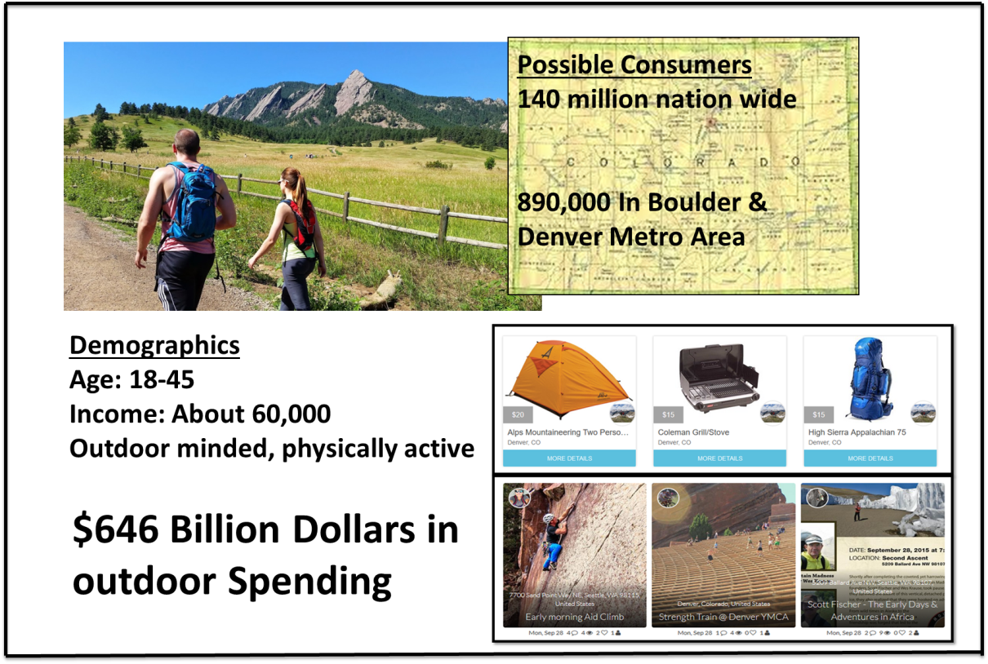

Figure 3: Overall target market diagram

The outdoor industry comprises a significant portion of the American economy, with $646 billion spent on outdoor recreation annually. Over 140 million Americans are regularly involved with outdoor recreation, and over 6.1 million Americans work within the outdoor recreation industry. Even during the recession, the outdoor economy grew at a 5% annual rate from 2005-2011. This growth rate is expected to continue through the year 2019.

Aging baby boomers and millennials make up the two largest age groups of the outdoor industry, so as the baby boomers become too old to participate in regular outdoor activities, rising millennials will fill in right behind them. Also, baby boomers are inclined to participate in more mellow, low-dollar activities like hiking where they can find peace and solace. Millennials tend to like adrenaline-filled high-dollar activities like skydiving and mountain biking, which should result in an increase in dollars spent on outdoor gear as more millennials come of age. Finally Generation X also enjoys many outdoors activities that are moderately rigorous, like mountain biking, and kayaking. GearShare is primed to capitalize on these potential markets with these three groups all enjoying outdoor sports.

## Addressable Market

The addressable market for our opportunity is tech-savvy outdoors consumers that are looking to try a new activity, but may not be able to afford the new equipment associated with that activity. On the conservative end, we would estimate that 75% of outdoor consumers are tech-savvy enough to work a mobile app, 25% of those consumers are willing to try a new outdoor activity regularly, and 75% of those consumers may not want to pay retail price to try an outdoor activity. 140 million people x 75% x 25% x 75% =19.6 million people, a sizable market segment for us to enter with very few barriers to entry.

The market segment we will be attempting to reach is the outdoor inclined demographic located in or around Boulder, CO. The socioeconomic class targeted would be middle class; the median income of Boulder is $67,956. Our product will focus on the low-cost segment of the market and provide members with a high-quality, inexpensive renting alternative to buying outdoor equipment at retail price.

## Industry Analysis

GearShare will face a number of barriers to entry, namely the brick-and-mortar rental stores in the Boulder area as well as rental shops directly at ski slopes and popular recreation locations. Fortunately, there is no non-rental sanction on retailed equipment such as is the case with software or many kinds of electronic hardware, so anyone who wants can rent out the gear they own. However, we provide the option to existing rental businesses to integrate their rental system with our online one, which could remove a substantial barrier.

GearCommons is a similar online competitor who crowdsources gear for rental on their website. GearCommons has had highly-localized success, with thousands of rental availabilities on their website around their home base of New York, while having only about thirty here in Boulder and no active community engagement. Gociety, like GearShare, offers the ability to be part of an online community of likeminded outdoor enthusiasts. GearShare offers what both its major competitors provide separately, putting it ahead of the competition. Local interest will be incredibly high, especially since this area is full of many outdoorsy young people who would likely be willing to rent out their gear to make money for college living expenses. Our financial barrier to consumer entry will also be rather low, having expenses only related to marketing, events, web presence and development, and management of our website. With the majority of the equipment used being sourced from equipment posting members, GearShare will not need to invest heavily in equipment.

## Competition

**GearCommons**: is an online peer-to-peer retailer of outdoor equipment with about 10,000 postings from individuals across the country. GearCommons places itself in the lowest price point bracket for the outdoor gear market. They allow for peer-to-peer exchange of equipment along with postings from brick and mortar retail stores. This company has many good characteristics, such as their detailed rental agreement and review system of both sellers and renters. On the other hand, GearCommons lacks a directed way to spread their service and provide an outdoor community.

**Gociety**: Gociety is an online social network made up of over 20,000 individuals who love the outdoors. Gociety enables its users to become part of a community that values adventure, healthy living, and positive social experiences. Gociety also allows its users to create and join outdoor plans and meet others who also share a passion for the outdoors. The Service allows its members to find adventures close to home or in a place they are visiting, but do not provide gear rental options.

**Brick and Mortar Rental Stores** The largest groups of indirect competitors that GearShare faces are brick and mortar specialized rental stores. Examples of these in the Boulder area for the snow and watersport industries are, Christy Sports, Boulder Ski Deals, and Rocky Mountain Paddle Boards. These providers are attempting to reach consumers at a higher price point then GearShare. The specialization and in stock inventory are the two main advantages of these competitors.

**Online Retailers Amazon & EBay**: The competitors that GearShare could face in the near future would develop from both online retailers, and brick and mortar rental stores. The large online conglomerates that sell or rent items, such as Amazon or EBay, could develop a peer-to-peer rental system. The advantages of these organizations are their customer base, infrastructure, and variety of gear options. These large online providers do lack the ability to create an inclusive and educational community. The brick and mortar retailers such as Christy Sports or Rocky Mountain Paddle Boards could develop online rental systems.

## Opportunity

Figure 4: GearShare Competition Matrix

We have chosen to implement GearShare in Colorado because outdoor recreation in the state generates $13.2 billion in consumer spending. The sharing of equipment has already been proven to be successful on the east coast by GearCommons. This competitor has not put as much effort into growing the company in the Colorado area, and therefore, has a significantly smaller share of the market in this region. This gives us the opportunity to take over the market in the Colorado area.

There is a great need for our service because equipment can be incredibly expensive and people included in our target market such as college students and middle class families may not be able or willing to pay the high prices that many local rental stores demand. Our company would not only allow for this market to have access to affordable equipment, but also enable members to make money off equipment they own.

Since GearCommons lacks viability in the Boulder area, and Gociety only provides a community; we have a real opportunity to penetrate this market successfully. If we market GearShare strategically, precisely and efficiently, we have the capability of growing rapidly given that the majority of Colorado residents fall within our target market.

# Marketing Plan

## Member Research

GearShare has reached out to possible members and found an opportunity for a community-oriented equipment rental and event sponsoring organization. Our target consumer is 18-45 years old with an interest in the outdoors. Currently, consumers seem to perceive our service as something similar to companies such as North Face, REI, or Patagonia. We need to help our consumer realize that we are attempting to fill the need of a community-based event planning service to help bring people together to increase confidence and skills in a cost effective and safe manner. Our target market would be willing to pay 10-15 dollars for a monthly membership and 15 dollars for a catered event. This is optimal as it fits right into GearShare’s pricing strategy.

## Member Profile

The typical mer profile GearShare is looking to attract either males or females, ages 18-45 years of age, and Caucasian with 87.7% of Colorado self-reported as Caucasian (Census Bureau). The median age of people in Boulder and Denver Metro area for Colorado is 27.7 years old. Our target market is educated, with 71.8% of the people in Boulder holding a Bachelor’s degree or higher and having a median household income of $56,312 (Census Bureau). GearShare would be a real draw to people who live near the mountains and with to participate in various sports, but don’t have the disposable income to purchase their own gear. Boulder is mainly a liberal minded, outdoorsy, healthy, educated, and environmentally conscious demographic. Boulder typically residents enjoy spending time outdoors and participating in healthy physical activities which GearShare will provide equipment and events focused on these activities.

Figure 5: Customer Profiles

## Buying Decisions

Possible members of GearShare will be looking to get involved with a community of people that have similar values to themselves, people looking to rent high quality outdoor gear, entrepreneurs looking to post gear for a profit, and small business looking to generate rental profit for their outdoor business. The largest deterrent to our service will be the relative utility a person feels compared to the price they pay. Membership will be $9.99 per month and provide one complementary event, unlimited gear postings, discounts on certain items, and preferred access to events. The ease of use and quality of service present in both the rental process and event attendance will draw people to GearShare. Having the opportunity to try new hobbies and develop practical skills will continue to bring members back to our business.

GearShare can be accessed by anyone with a computer or smart phone. The main transaction form will be via credit card charges. There will be a monthly charge to the new member’s credit card once they have become a member, and they must choose to cancel the membership. The purchasing of rental equipment will depend on the member’s needs but, payment will still be processed with a credit card. From there, members will arrange how they will obtain the equipment with the person they are renting gear from. Sale of new equipment from retail partners will occur on our website as well. Members are able to attend one complementary event per month; walk up participants will pay with cash or credit card. The bar where attendees can buy drinks will be cash or credit as well.

## Member Behavior

The target members would be accustomed to using social media and electronic devises for communication. We will mainly use marketing at rec centers and other outdoor areas to draw in possible consumers. We will also use electronic marketing on sites where people looking to get involved with outdoor activities frequently visit, how to websites, trip reports, equipment purchasing outlets. Currently, there is no company that offers cheap rentals with the opportunity to attend separate community events to develop skills and meet others. We are confident that our target consumer will be drawn in with these features that help provide an inclusive space to grow and learn.

## Channel Strategy

GearShare will strive to connect both members and non-members alike using our website and events. By streamlining our communication and ease of access with the website we can help reduce confusion and increase the amount of gear rented. E-Commerce will be our main channel for providing services to the member. The member will log onto our website with a computer (Apple or Windows) or smart phone app (android, IOS, or windows) in order to rent gear by category or list their equipment for rental. An online database will track member information as well as points earned by renters and lenders through their activity. We will get retailers, distributors, wholesalers and manufacturers involved by offering coupons to these stores in exchange for points acquired by the user from their activity. The website will also have space available for targeted advertising for gear sellers towards member’s rental tendencies. It is important that we market the ease of use present with the GearShare website and eventually the app so that people can see the value and understand the fees associated with our service.

## 

## Positioning

Figure 6: GearShare Channel Strategy Diagram

GearShare focuses on developing an inclusive community that provides educational and skill development seminars. These community-driven meetings will also allow GearShare to recommend equipment on our website via a peer-to-peer option or outdoor retailers. GearShare hopes to differentiate itself from other rental services by providing an inclusive learning environment for novice outdoorsmen to learn and develop their skills while also finding people to spend time outdoors with. The events will be open to the public but members will have early notice and registration opportunities, while also gaining reward points by attending and renting from GearShare.

## Brand Identity

Figure 7: GearShare Brand Identity Diagram

GearShare wants to project an identity of inclusivity and educational support. We want consumers to see our service as an avenue to acquire outdoor skills, meet new people, and become active in the outdoors. Along with educational services, GearShare will provide new gear recommendation and peer-to-peer renting services to provide the lowest cost options possible for our members. The look and feel of our website, app, logo, and events will be easy for the customer to use and pleasing to the eye. Limiting the intimidation factors associated with learning a new skill will be crucial to helping our event attendees not feel judged for their novice skills. The member experience that GearShare wishes to provide is one of clear communication through the website and app. GearShare wants it’s members to think of GearShare as their go-to community where they can connect with people and find a new interest in the outdoors.

## Digital Strategy & Communication Strategy

GearShare plans to invest heavily in digital outreach strategies. First, we plan on setting up social network accounts or groups on Facebook and Twitter that discuss upcoming deals, meet-ups, lessons, seminars, etc. and hope to link them back to our website to generate traffic. The website itself will have a news feed that is updated frequently with news and interviews from people involved in our target outdoor market. We also plan to monitor website traffic to see what articles, advertisements, or deals are most effective in increasing popularity of our company as a method of micropivoting towards the most profitable avenues for income. GearShare also hopes to be able to tap into affiliates like ski resorts, rec centers or local outdoor guides in order to help promote GearShare’s rental service, lessons, and activities to help increase active members in the outdoor community.

## Sales Strategy

            In the beginning, one of GearShare’s main focuses will be to make our website error free and extremely easy to use, which will help us facilitate gear sharing. We plan to accomplish this by hiring a Chief Technology Officer to develop the website and app. He/she will also be responsible for performing maintenance and fixing bugs as they arise. If we can provide a great look and feel to our website, members will be drawn back and feel encouraged spreading the word to their friends and family.

However, as GearShare expands in popularity and begins to have events more frequently or even on the same day, GearShare will need to hire part-time volunteers/salespeople in order to staff our events. GearShare will look to hire bright young individual from the Boulder community who are energetic and passionate about the outdoors. They will be compensated with a standard hourly wage, as well as a commission of 2.5% on every membership they sell, and will be trained about GearShare message and how we want them to present themselves to the community.

## Pricing Strategy

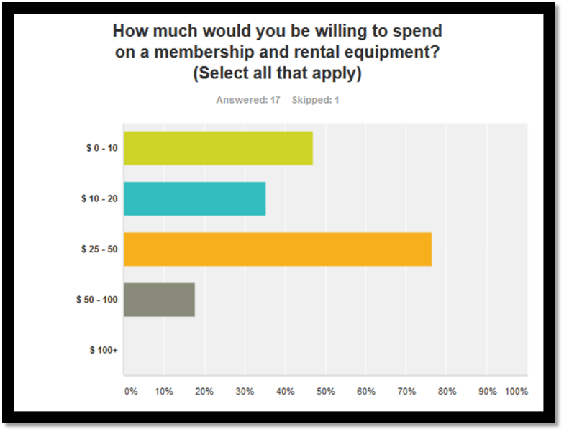

Figure 8: GearShare Price Point Survey Results

As part of our market research, we asked our potential members how much they would be willing to pay on a monthly basis for our services. The majority of people responded positively to the monthly range of $25-$50 if that would include their membership fee and rental of 1-2 items. Based on these results, we think $9.99 is a reasonable membership fee to charge in exchange for unlimited postings and rentals on our site, as well as one free admission to a GearShare event. In addition, we offer a three month membership for $24.99, giving incentive for our members to commit to using GearShare on a regular basis for a longer period of time.

We will charge a flat fee of $15 to attend GearShare sponsored events in the local community and other outdoor locations. The $15 was determined to include our costs associated with hosting the event. There will be a bar selling both alcoholic and non-alcoholic beverages, but food will be included in the $15 entrance fee. The strategy for renting and buying gear is to provide a floor and ceiling limit to stop undercutting while providing recommendations based on MSRP. There is a $10 minimum on any type of gear rented out, no matter what the timeframe is. From there, gear will be rented on a daily basis, with the owner of the gear determining the prices. GearShare will take a 20% cut of each sale or rental final price. The website advertising portion of GearShare’s pricing strategy will be based on a pay per click revenue model. We will rent out website space for banners from REI, Patagonia, and other outdoor retailers. The prices for advertising on our website will start at $300 per month and increase in cost as website traffic increases. GearShare will also get paid s standard $0.10 for every time a member clicks on a company’s advertisement.

## 

## Revenue Model

Membership

Our memberships will be a source of pure profit, since membership is an abstract good that we can sell to anyone willing to pay the money without incurring direct cost. Those cost elements that do exist are spread across the memberships acquired: advertisement, food, travel expenses to attend events, and various goodies, food and drink we plan on giving out at events.

However, where our membership model differs from most others is our anticipation of very rapid growth in the years to come, as GearShare will heavily emphasize community organization and management, as well as create a positive experience for our consumers. These elements will help add word-of-mouth advertising advantages to our marketing plan and general sales scaling through happy members. As of now, our revenue projections are anchored in our initial launch market of Boulder, Colorado. This is where there are a very large number of healthy, outdoor-minded, active, and moderate-income young people live, which we believe will take onto our market quickly.

Gear Rental

Our price point and anticipated transaction fee are both priced according to an estimate of average rental price to the member. Additionally, our growth is conservative to account for the potential displeasure on the part of the gear-lender at the lack of truly substantial income. GearShare will implement a security deposit feature in order to protect poster member equipment and increase confidence in renting equipment. Also, GearShare will have a renter/lender rating system. The growth of the gear postings is estimated based on the assumption that half of our members post rent 1 item per month, a conservative estimate of growth.

Events

The GearShare events will be held twice per month at locations that will strive to bring GearShare members and their equipment together. Using the results of the survey to gauge GearShare interest, about 55% of people would use our service. GearShare assumes that 50% of our members will attend our events, and if each of them bring one interested friend, GearShare can assume that will be our general event attendance. Our main event costs will be our tent, GearShare logo banners, wireless hotspots, and tables & chairs. For our event venues GearShare will target ski resorts, trailheads, and local parks, which could cost up to $750. GearShare will have food catered by local businesses that GearShare will let advertise cooperatively with our events. With our assumption that our membership base would grow by 50% the first year and 100% into the third year, our non-member attendance should increase with a conservative estimate of 20% of those expected increases. With an average event costing $1200 dollars, and the cost to attend the events being $15, GearShare will need about 80 people to attend in order to break even.

1. Location – Permit or Event Registration $**500**
2. Food – Enough food and beer/drinks for 15-25 people $**200-500**
3. Entertainment* – A speaker or industry specialist to hold a seminar or skills workshop $**500-1000**
4. GearShare Logo & Advertising – Printed GearShare brochures and stickers $**100-150**

Advertising

GearShare can assume that each of our members is visiting our website and smart phone app at least three times per day, which is a conservative estimate, as most people pick up their phone 1500 times per week. GearShare will have a $.10 per click charge for people accessing the advertising company’s website from our own. The revenue from advertising will be based primarily on the click charges but GearShare will also charge a monthly fee for hosting the companies’ advertisement on our website.

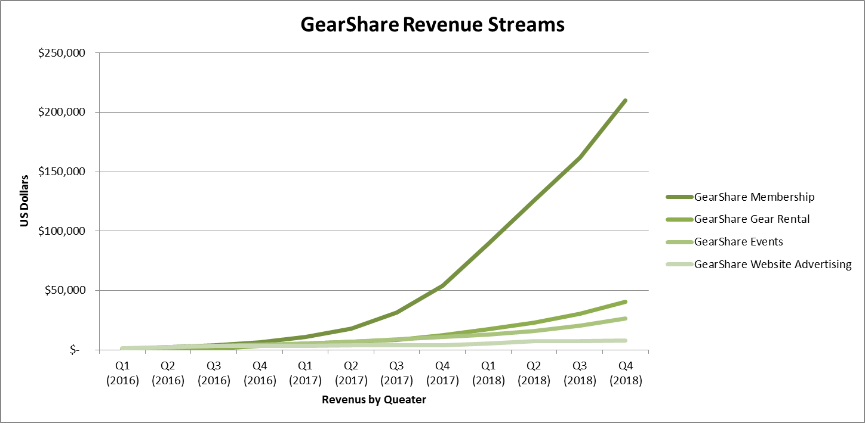

Figure 9: GearShare Revenue Streams

# Operations Plan

Introduction – The GearShare System

GearShare will be developing and creating an outdoor community via two main outlets, the first being a well-designed website and the second being sponsored events. GearShare’s website will have many functions such as:

* individual profile creation
* instant messaging
* “news feed” or real time display of spontaneous events being held by users
* events calendar
* peer-to-peer gear rental postings
* spaces for retailer recommendations and advertising

The other main way GearShare will be reaching the consumer is through our events. GearShare will be holding outdoor themed events about twice per month. These will be focused around a skills workshop and provide a space for members to meet, mingle, and swap gear if they would like. These events will be a staple in our strategy to create a functional and thriving community within GearShare, so it is essential that GearShare make these events fun, entertaining, and inclusive.

## Operations Strategy

GearShare will focus most of its advertising efforts on targeting people new to the outdoors. We will use Facebook, Instagram, and Twitter as our three main platforms of outreach through social media. We will also visit local recreation centers, civic centers, and high traffic areas to post flyers to promote GearShare. Using all of these methods to advertise, GearShare will have many more touches with possible new outdoors people. The other operational aspect of our advertising plan is to recruit businesses to advertise on our website. We will be reaching out to outdoor retailers and outdoor activity providers to advertise on our website. With a membership base that is new to the outdoor industry, we have a unique appeal to these companies as our members will be more likely to purchase their goods or services. We will do this by having a designated sales person who will contact and meet with local businesses using the consultative sales techniques to build long lasting relationships.

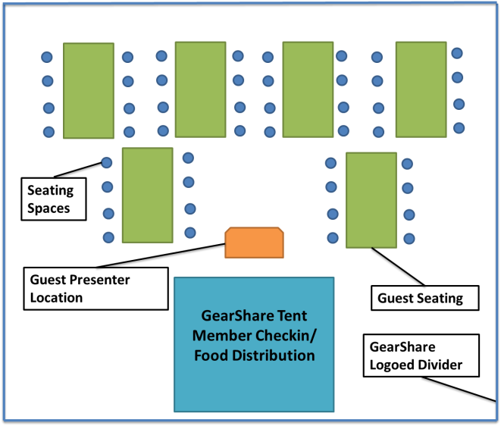Hosting events for GearShare members will provide a unique opportunity for our members to come together and spend time developing skills, swapping gear, and meeting other individuals. These events will be a great way to provide an important service to our members while also allowing us to perform specific marketing to the outdoor community we are trying to reach.

Figure 10: GearShare Event Set Up Diagram

## Scope of Operations

GearShare’s production costs will be limited, but our events will need a well-defined operations procedure. The operations we will manage in house are the events advertising, recruitment, and sales in house as well.

The GearShare team will be handling these events in house. We will store our EZUP Canopies ©, GearShare banners, and tables and chairs in our office. We will be transporting our equipment to sites using a GearShare trailer. GearShare will operate the events by purchasing tents and other pop up booths that we can set up at given locations the day an event is scheduled to occur. In order to make this possible, several costs will be required. We will need an office space to store our equipment, nonperishable beverages, and promotional merchandise. Since the materials that we will be transporting are not incredibly valuable, it would be safe to go for a trailer on the lower pricing spectrum and spend no more than a couple thousand dollars.

GearShare’s operations for its website and phone application would be run by a programmer hired to maintain and update our two platforms. The main focus will be ensuring an issue free platform for our members. The programmer and the other members of the GearShare staff would all be responsible for fielding member support emails and phone calls during business hours. The local Boulder company Insight Design Web Solutions, LLC will be our go-to developer for helping to design and implement our website. With their background in design, e-commerce, marketing, and content management, they will be able to help us create an outstanding product (Designs, 2015)

## Research, Development, and Engineering

GearShare has a model to follow by learning from our competitors in GoCiety and GearCommons. We have improved on these ideas and generated an operational strategy and diversified revenue sources to help increase features to our member. The first month of development will be focused on working with our website designer and building our final website. We have to make sure our website is functioning well and very intuitive before we begin any of our testing stages. We are allocating a month of development and alpha testing followed by a month of beta testing with the CU Alpine Club to ensure our site won’t be difficult to navigate. The website will be considered our intellectual property and we will register it as a copyright to protect our design and layout from being stolen by our competitors.

# Key Milestones

As GearShare begins to get the gears turning, there are a few major milestones that will define our business’s success or failure. At the beginning, our primary goals will be to maximize the effectiveness of our advertising and recruit as many new members as possible. A good milestone for our business is reaching 10,000 members, approximately 2% of the Denver metro area population. We expect to reach this number near the end of year 2. Accomplishing this membership milestone will signify that our advertising has been effective and people are spreading the word about GearShare.

Another major milestone is reaching 500 gear postings on our website. We are forecasted to reach this number about 9 months after starting our business. This milestone will indicate a sufficient level of membership activity and interest from our target market. A very important aspect of our business is earning the trust of outdoor gear owners so they are willing to loan out their gear, and this milestone is important to validate the legitimacy of our business.

The other major aspect of GearShare, events, will also be a large source of income and therefore must have a meaningful milestone associated. This milestone will be 100 people in attendance at each event, which we expect to hit at the beginning of year 3. This is a fair estimate because of our expected membership of over 10,000 at the beginning of year 3, in addition to members’ guests and other non-members that will be welcome to attend. One hundred people attending every event will signal enough interest in our events to justify marketing to well-known outdoor experts to run our skills workshops and booking larger venues to hold our events, both of which will drive interest and continue to ramp up our membership numbers.

Perhaps our most significant key milestone is the expansion from Boulder to Denver. We have planned for this growth at about the middle of the second year, where our membership numbers really start to spike up. This expansion is crucial to jumpstart the number of postings and website traffic we will expect on a daily basis. The Denver market also brings a wider variety of gear, diversifying our gear collections and reducing the seasonality of our business.

# Management Plan

**CEO - Troy (TK) Coody III**

TK Coody will be graduating from the University of Colorado Boulder with a degree in Molecular Biology and a Minor in Business Analytics. His passion for the outdoors started at a young age where he loved hiking, biking, and fishing. His leadership skills as a mentor resident advisor provide him with a strong background in time management, leadership, teamwork, and conflict resolution. While also working as a campus tour guide TK’s public speaking and customer service skills have been well practiced.

**CFO - Connor Guerrieri**

Connor is brings a background in computer software and financial modeling. He loves spending time outdoors playing tennis and hiking. Connor has participated in Startup Colorado, including meeting with several successful Denver and Boulder startup leaders who passed on key insights to the risks and opportunities involved in starting a company. His knowledge of financial models and understanding of software and application development will help give GearShare a firm financial and technical understanding of what lies ahead.

**COO - Davis Kigin**

Davis has a background in project management and is highly motivated for success. Having worked for several large construction companies he is well versed in project management and being able to see the whole picture and ensuring everything is running smoothly. He will be graduating with a degree in Architectural Engineering with a focus in construction management and a minor in business. He will provide the operational prowess needed to keep GearShare functioning like a well-oiled machine.

**VP of Marketing and Sales - Jackie Carroll**

Jacqueline will be graduating from the University of Colorado Boulder with a degree in Psychology and minor in Business Analytics and Innovation. Having had previous sales experience as a sales associate at the Sunglass Hut and field marketing experience with a company that has one of the best marketing strategies in the game, Red Bull North America, Jacqueline is well prepared to take on the Marketing and Sales of GearShare. Jacqueline’s persistence and ability to problem solve will ensure GearShare’s membership ship sale will be successful.

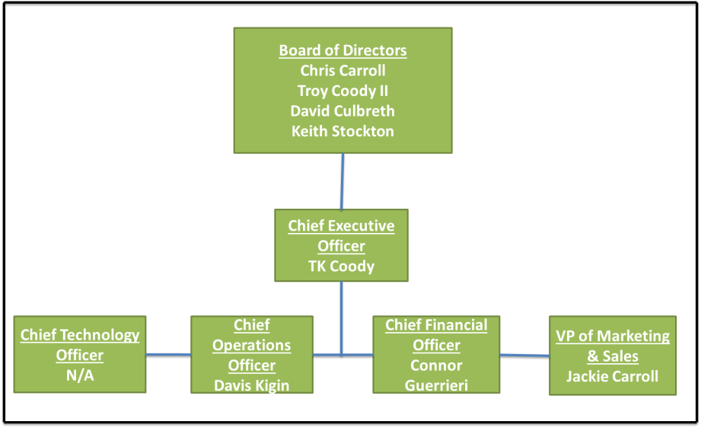**Board of Directors**

David Culbreth - Cloud computing expert for OpenSky Corporation with previous startup experience in the technology sector.

Troy Coody II - Network Security professional for IBM with previous entrepreneurial experience

Keith Stockton - Professor at the University of Colorado Boulder with previous experience in operations engineering for IBM.

Christopher Carroll - CEO of Agency Desk with a background in financial investing and entrepreneurship.

Figure 11: GearShare Organization Chart

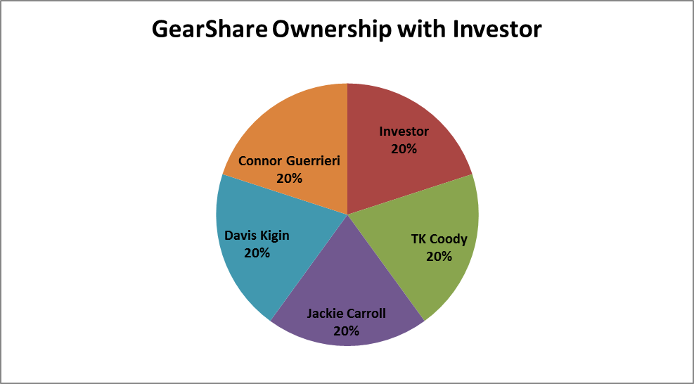

Figure 12: GearShare Ownership Diagram

# Risks

Market & Social Media Growth

The assumption made on outdoor interest in sporting activities is backed by government research and the Outdoor Industry Association. Persons looking to enter the market may have committed to the outdoor sport(s) of their choice and couldn’t see the value in renting gear or may still be too intimidated. Our growth through social media is also a worrisome risk as it depends on our ability to penetrate our market. Our plan for mitigation for this is to both ensure that gear lenders are being fairly compensated by implementing a recommended minimum rental fee per day based on the MSRP and relative quality of the item being listed, along with implementing a security deposit in the event of gear misplacement and damage. This will control pricing and ensure that people are not scared away from renting. When it comes to offsetting the social media branding and growth risks we will be having other methods of outreach to possible consumers, web adds, posted flyers, advertising at rec centers and outdoor recreation areas. This will allow us to not only increase visibility but, also tie in our social media efforts by mentioning and posting it at all of these locations as well.

Competitor Response and Predatory Pricing

Our most significant competitors include those with long-term rental facilities at an outdoor activity location. One risk that is most possible is that they suddenly plunge their prices. However, GearShare will be constantly holding significantly cheaper events as well as offering their usual gear for rental at a fraction of the cost, food included. They, on the other hand, cannot afford to cheaply rent out gear, as they have to pay for multiple full-time employees, land costs, multiple utility fees, maintenance for equipment and vehicles. Our only other true competitor of a similar nature, GearCommons, offers only online gear sharing, not events of any kind, and have postings almost entirely along the East Coast with very few (<30) listings in Boulder, CO and other cities in the West. As such, we expect very limited encroachment on our online business, let alone for our events. Gociety offers free meetup services, but is only really structured to attract already-involved outdoorspeople who likely already have their own gear and financial means, so will not likely clash with our target consumer base.

Operational: Event Costs and Popularity

GearShare’s largest operational risk will involve the hosting of GearShare events. We want to make sure these events have consistent and quality service so that members and walk-ups alike have a great time and want to return. We will manage this by developing a seamless process that we can repeat for each event and modify as needed to make sure it fits the needs of our guests. Reaching the necessary food cost margin will be mandatory. Waste of perishable goods will kill our bottom line, therefore we will use our initial events as trials to ensure we can find the best food cost to guest ratio.

Technology: Development Time and Cost

At the most basic, the website is can be developed from current social networking models. The costs are expected to be *at most* $25,000 for a high-quality, robust, appealing, functional website, and we will be able to manage and update. Our CFO Connor Guerrieri will oversee its management until we can fill our CTO position on the GearShare team. We will only need to copyright the website processes, code, and design, a very routine and easy process. However, the time to develop the website and eventually the accompanying app may be a potential risk in terms of delaying the upstart of the business. Most high-powered website developers will be completely capable of putting websites of this moderate scale together within a few months.

Financial: Seasonality & Funding

GearShare’s major financial risk is being able to secure a worthy, industry-knowledgeable partner who can help offer valuable advice and contributions as we navigate the choppy first year of operations. Receiving the necessary funding is always a challenge but, GearShare will also operate on a seasonal business plan. Although we appeal to winter sports finding gear that fits accordingly can be troublesome. Therefore, we will increase event participation by focusing on bringing in ski and snowboard professionals along with winter outdoor professionals.

# Financial Plan

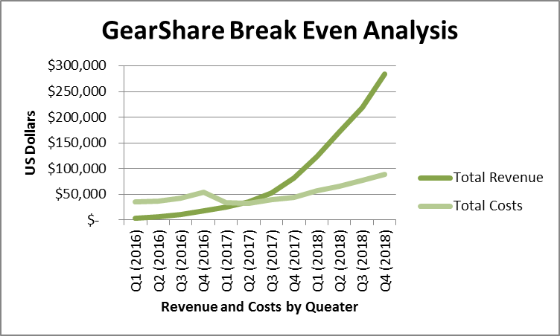

Figure 13: GearShare Break Even Analysis

GearShares current financial model indicates that the firm becomes profitable June the second year of operations this is described in our break even analysis below. Our required startup funds include the margin GearShare possesses is one of the best attributes of GearShare’s financial descriptions.

GearShare will develop of a website, and the purchasing of event equipment and additional rentable outdoor equipment to be posted on the website. The ability of GearShare to generate the revenue described primarily comes from the monthly membership fees and gear rentals. The events do provide a large portion of the revenue, but due to their seasonality during the colder months in Colorado, they have a smaller role in the revenue stream. Although our liquidity ratio is only 0.7 for the first two years, it quickly jumps up to 2.2 in year three.

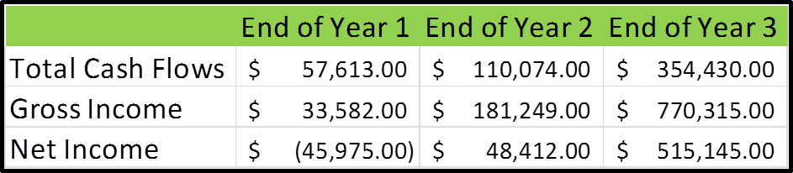

Figure 14: GearShare Important Financial Elements

## 

## Key Drivers

GearShare has 4 revenue streams which include membership, peer-to-peer gear rental, events, and website advertising. Our membership and rentals will provide the largest portions of our revenue streams due to the high return and margins on these two items. The advantage that GearShare has is the minimal startup costs needed, along with the opportunity of rapid growth due to the ties to social media and the interest in outdoor activities currently.

The GearShare revenue streams will be limited by the success generated to convert potential members with events and membership opportunities. We will be keeping our membership and event fees at a low price point, $9.99 per/month and $15.00 per event, with hopes of increasing volume to meet our profit goals. The more we reach our target market, the better chance we will have to grow our membership base to the needed size. The high profit margins on the membership fees, events, and gear rentals are very favorable to GearShare’s revenue generation. With our low operating and R&D costs, we will be ahead of the game in managing this portion of our business. Finally, the last main driver of our business is our ability to grow membership quickly by word of mouth and targeted advertising. We have also included conservative estimates in our membership growth and other revenue streams to help create an accurate as possible financial model. Again, due to our low price point and variety of activities, GearShare stands as the perfect faucet for individuals to become involved in the outdoor community.

Figure 15: GearShare Funding Summary Table

## Required Startup Funds

GearShare will have a limited requirement of startup funds since we only anticipate buying a trailer, event hosting equipment, and outdoor gear to pre-stock our rental system. The total estimated cost is approximately $20,000 for all of the needed hard assets GearShare needs to begin operating. GearShare will also need $25,000 in order to cover the costs of hosting, hiring a full stack developer prior to the start of operations to build a website, along with a designer who can help implement a simple, powerful look that will appeal to visitors to our website. We will then expand into developing our smart phone app once we have an established member base.

# Funding Plan

The majority of GearShare’s funding will be going directly to the design and implementation of our website. GearShare is open to options of either debt or equity financing. The ability to bring on an equity investor with experience in the technology or outdoor sectors would be ideal to help provide support and guidance. The initial startup funds needed by GearShare will be $40,000 with an additional $70,000 to help cover the first year losses as GearShare becomes profitable June of the second year. We have also built in a 10% cash buffer into our startup costs to cover incidental and unforeseen costs.

Our funding plan consists of raising initial capital needs to begin the venture and cover the losses for the first year. Throughout this period, GearShare will be working on minimizing our budget and using the bootstrapping technique to help make sure the outflow of cash will be limited. After the first year, GearShare will begin looking for investors to help increase capital and allow us to begin developing a phone application and improve the website capabilities. GearShare hopes to continue expanding to new parts of the United States and to other countries, at which time it will be necessary to obtain additional funding. The initial loan and investment amount will go into funding the development, implementation, and testing of our website. We valued the development of our website at this price point because our website’s functionality and visual appeal are crucial to the success of GearShare. GearShare’s conservative financial model has positive cash flow values starting June of the second year. With the cash flows increasing into our third year, GearShare has built in the ability to pay off all of its financing by the third year in hopes of being able to begin generating more funding for further expansion.

**Equity and Debt Funding**

GearShare will be looking for bringing on an outside investor to invest $35,000 to help cover initial start. This will be for 30% equity stake in GearShare. This will allow the firm to not only have a debt free source of financing but, also provide valuable knowledge from a previous entrepreneur who can help guide GearShare in the right direction. The other portion of GearShare’s funding will be from small business loans, depending on the amount of equity funding received GearShare will look into a loan for either $35,000 or $70,000 dollars. U.S. Bank offers small business, SBA, and loans for Business Ownership and Expansion. The money granted may be used to finance business acquisition, equipment, debt refinance, working capital, inventory, and tenant improvement (Bank, 2015). We would be requesting a loan for $35,000-$70,000 with a 2.91% interest rate. (Journal, 2015).

# Appendix



**Income Statement Year 1**

**Income Statement Year 2**



**Income Statement Year 3**



**Cash Flows Year 1**



**Cash Flows Year 2**



**Cash Flows Year 3**



**Balance Sheet Year 1**



**Balance Sheet Year 2**

**Balance Sheet Year 3**

**GearShare Income Statement Year 1**

**GearShare Break Even Analysis**

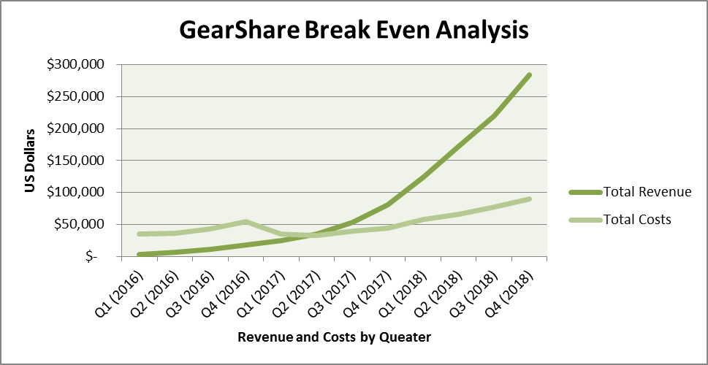

**GearShare Cash Flows**

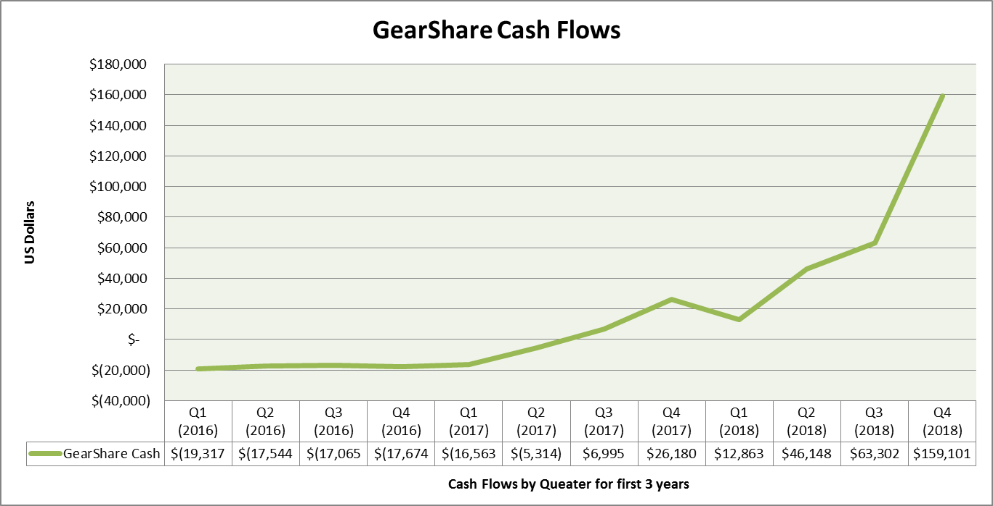

**Troy Kirkland Coody III**

10484 Plateau Rd. Longmont, CO, 80504 – 303-775-0712 – [troy.coody@colorado.edu](mailto:troy.coody@colorado.edu)

**Summary**

Hard working, team oriented, and technically experienced molecular biology undergraduate searching for a graduate school position focused on improving our understanding of cancer and cell biology structural elements in hopes of benefiting the human condition.

**Education**

University of Colorado - Boulder, Colorado August 2012 - May 2016 (B.S. Molecular Biology GPA: 3.48)

**Professional Experience**

Undergraduate Researcher in Odorizzi Lab - CU Boulder - August 2013 - Present

* Developing novel experiments and constructs to understand the effect of Bro1 on the ESCRT pathway through immune-precipitations and western blots under conditions of specific ESCRT-III protein overexpression, Vps2, Vps24, and Bro1.

Lab Technician in Odorizzi Lab - CU Boulder - January 2013 - Present

* Increased lab efficiency and helped reduce waste and costs in reagent production.

Advanced Bacteriophage Freshmen Lab Course - CU Boulder - August 2012 - May 2013

* Learned basic molecular biology techniques while isolating a novel bacteriophage (see publication)

**Selected Skills and Techniques**

Molecular Biology Techniques

* Protein Gel Electrophoresis
* Western Blot
* Immunoprecipitation
* Cryogenic Lysis Procedure
* DNA Isolation
* PCR, primer construction and cloning
* Transformation of yeast
* Transformation of bacteria

Computer Skills - word processing, presentations, spreadsheets, database and cataloging

Leadership - exceptional communication skills, team oriented, organizational, public speaking

**Publications**

Pope, Welkin H., Charles A. Bowman, Daniel A. Russell, Deborah Jacobs-Sera, David J. Asai, Steven G. Cresawn, William R. Jacobs, Roger W. Hendrix, Jeffrey G. Lawrence, and Graham F. Hatfull. "Whole Genome Comparison of a Large Collection of Mycobacteriophages Reveals a Continuum of Phage Genetic Diversity." ELife 4 (2015): n. pag. Web.

* Identified a novel bacteriophage from an aquatic eco-system. Analyzed through EM morphology, PCR, and restriction enzyme digest. After sequencing the novel phages genome my class and I annotated the genome and performed BLAST data mining to be used for this publication

**Teaching Experience**

MCDB Undergraduate TA - July 2015 - Present

* Taught and mentored students in 2 lab sections of Intro to MCDB and Genetics courses.

Leeds School of Business Marketing TA - January 2015 - Present

* Maintained and streamlined tasks and grading for upper division classes

Geology Teaching Assistant - August 2013 - May 2014

* Mentored students by providing review sessions for tests and weekly homework help sessions

MCDB Mentor - October 2013 - Present

* Tutored underclassmen at study sessions in MCDB Intro, and Genetics

**Honors & Awards**

BURST Undergraduate Research Grant - CU Boulder - August 2013 - May 2014

UROP (Undergraduate Research Opportunity) Grant - August 2014 - Present

Resident Advisor of the Year Nomination - August 2013 - May 2014

UROP Ambassadors Representative - August 2015 - Present

**Leadership Experience**

RAppin conference Attendee - October 2014

* Selected to attend a Resident Advisor conference in New Mexico

CU Student Ambassador Team Lead - September 2014 - Present

* Selected to represent the CU Office of Admission as a volunteer tour guide and team leader. To provide guided tours of the university for prospective students and their parents or guardians

NRHH (National residence Hall Honorary) Executive Board Member - October 2013 - May 2014

* Facilitated the monthly award system and weekly recognition programs for NRHH and managed the website

MCDB Mentors - September 2012 - Present

* Mentored 1st and 2nd year MCDB students to ensure their success at CU in MCDB

**Work Experience**

University of Colorado Resident Assistant - August 2013 – Present

* Fostered the development of an inclusive community of 30-45 first year students. Maintained the well-being of 450 residents while dealing with high stress situations and developing 1 to 1 connections to increase retention.

Winter International Student Resident Assistant - January 2014 & January 2015

* Helped assimilate international students to life at CU through a week long orientation session. Developed personal connections and helped foster the inclusion of internationals students.

Ute Creek Golf Course Crew Leader City of Longmont - March 2010 - August 2014

JACQUELINE CARROLL

2915 Baseline Road, Apartment 320, Boulder City, CO 80303 | C: 917-757-3442 | Jacqueline.Carroll@colorado.edu

**EDUCATION**

**Bachelor of Science**, **Psychology** Dec 2015  
University of Colorado at Boulder - Boulder, CO, United States  
**Minor in Business** - Focus in Business Analytics and Managing Innovation

**PROFESSIONAL EXPERIENCE**

**T’aco Restaurant** Aug 2015 to C*u*rrent

**Intern** – Boulder CO

Experience observing the inner workings of a small company with practical experience working with marketing, advertising, and analyzing financial statements.

**Sunglass Hut** Jun 2014 to Oct 2014  
**Sales Associate** - Boulder, CO

Sold sunglasses, counted inventory, opened and closed store, mastered Ciao computer  
program, and made cash deposits to Wells Fargo.

**Red Bull North America** Jul 2012 to Feb 2013  
**Wings Team Member** - Denver, CO

Focused on field marketing the product throughout the state of Colorado.

**Samurai Trading LLC** Jul 2009 to Aug 2011  
**Trader's Assistant** - New York, New York

Worked during the second part of three summers with mean revision strategies, electronic  
trading, US equity securities.

**Morro Bay Surf Company** Jun 2008 to Jul 2009  
**Surfing Instructor** - Morro Bay, CA

Worked two summers during the month of June teaching children to surf, cleaning  
equipment, and organizing private lessons.

**SKILLS & AWARDS**

Certified Yoga Instructor Core Power Yoga Boulder, Colorado (2015)

Competitive Mogul Skiing Training  
Ski and Snowboard Club Vail, Colorado (2008-2011)

Mogul Skiing Training (Gymnastics) at WOGA Gym, Frisco, Texas (2009-2011)

**Davis Kigin**

802 University Avenue, Boulder, CO 80302 • davis.kigin@colorado.edu • 303-809-9956 • https://www.linkedin.com/in/daviskigin

**EDUCATION**

**University of Colorado at Boulder – College of Engineering and Applied Science** May 2016

Bachelor of Science in Architectural Engineering, Emphasis in Construction Management

Minor in Business

Major GPA – 3.3, Cumulative GPA – 3.14

* ***Relevant Projects:*** Part of a team that designed a double envelope passive solar home for Engineering Projects class, moderating indoor temperature fluctuations within 10 degrees between day and night.
* ***Relevant Courses:*** Intro to Construction, Project Management 1, Business Methods & Economics for Engineers, Engineering Drawing, Marketing & Management, Accounting & Finance
* ***Study Abroad – Culture Wars in Rome:*** Spent two weeks in Rome, Italy in May 2015 studying history and culture.

**Occupational Safety and Health Administration** June 2014

30 Hour Construction Certification

**PROFESSIONAL EXPERIENCE**

**Mortenson Construction,** Phoenix, Arizona June 2015-August 2015

*Integrated Construction Coordinator Intern, Full-Time*

* Assigned to SRP Renovation project in Tempe. Modeled pipe and conduit in AutoCAD, imported models into Navisworks to run clash detection. Built virtual mock-ups in Sketchup, created sequence of animation to explain potential issues.
* Supported BIM Coordinator by preparing models for Oculus Rift, stitched together point clouds from Laser Scanner.

**JE Dunn,** Boulder, Colorado September 2014-May 2015

*Intern, Part-Time*

* Assisted with closeout on Central Utility Plant project on CU Boulder Campus; collected maintenance manuals and warranties from about 20 subcontractors, created and assessed fines for over 100 tickets on the punch list. Responsible for writing and helping resolve over 200 RFIs and Submittals, managing document libraries and uploading them to project site.

**Turner Construction,** Denver, Colorado June-August 2014

*Intern, Full-Time*

* Assigned to the GoGo Wireless Relocation project in Broomfield, Colorado. Assisted the Project Manager, Project Engineer, and Superintendent on various tasks ensuring the project stayed on budget and on schedule.
* Created ~20 RFIs and Submittal Packages, assembled Pre-Task Planning sheets and Daily Construction Reports from foremen on site, and made ~400 phone calls confirming contact information for the master bid list.

**Jacobs Engineering** December 2011

*40 Hour Job Shadow*

* Attended department meetings, counted various items on the drawings, and helped organize drawing sets.

**LEADERSHIP**

**University of Colorado Club Golf Team** August 2015-Present

*President*

* Grow club golf at CU by advertising and recruiting players from the CU Campus. Organize and pay team dues each semester, set up team meetings and social events, act as point of contact between NCCGA and team.

**Sigma Phi Epsilon Colorado Alpha,** Boulder, Colorado February 2013-Present

*Philanthropy Chairman*

* Coordinated first annual spring philanthropy event, "Checking for Cancer," an All-Star hockey game with two teams composed of players from 10 different fraternities at CU. The event has raised a cumulative $20,000 over two years, with all proceeds benefiting the V Foundation for Cancer Research.

**Associated General Contractors Student Chapter,** Boulder, Colorado August 2014-Present

*Executive Board - Secretary*

* Maintain attendance sheet for weekly meetings, update member contact information, and advertise through social media.

**SKILLS & AWARDS**

* Proficient in Microsoft Office, Primavera P6, Laser Scanning, Bluebeam, AutoCAD, Revit, Navisworks, Sketchup, 3DS Max
* Awarded scholarships: AGC Foundation, Clarence Eckel Memorial, David DeCook, Bernice Schultz, Business Minor

**Connor L. Guerrieri**

*4444 Gladiola Street*

*Golden, CO 80403*

*Tel:* **708-927-9886**  
*Email:* **Connor.Guerrieri@Colorado.Edu**

**EDUCATION**

University of Colorado, Boulder

Cumulative GPA: 3.1  
B.S. in Engineering, Computer Science, Software Engineering Track (December 2015)  
 - Minors in **Business** and **Philosophy** (December 2015)  
Chancellor’s Achievement Award

Honors Program (Top admitted students)  
Stampede Leadership Program (competitive admission)Scholarships: Zazove Foundation, Illinois Audiology Association, Hotchkiss Foundation

Lime Connect Fellow, Class of 2013 (<http://limeconnect.com/>)

**TECHNICAL PROFICIENCY**

* Programming Languages: C, C++, Java, Python, CSS, HTML
* Experience with SQL and MongoDB database creation and management
* Github, TortoiseSVN source control
* Proficient in Word, Powerpoint, and Excel (including financial modeling)

**EMPLOYMENT**

* McGraw-Hill Financial, Intern, Data Collections (June 2014 - August 2015)
  + Write/adjust/fix scheduled data-collection Python scripts, as well as conduct database and stored procedure management for the collected data in the resident SQL database, assisting other team members.
* Phobic Studios, Programmer (Fall 2012)
  + Wrote parser program for Mac .plist files in Qt C++ to non-mac systems to assist developers for game development project. Worked independently but actively recruited the help of several other programmers.

**ACADEMIC/RELATED PROJECTS**

* Wrote 3D wire-frame interactive viewer with C++ in EMACS environment (Fall 2011)
* Assisted minor scripting for game development using Javascript in Unity (Summer 2012)
* Helped create a web interface that created and stored recreate-able atmospheric modeling workflows for the National Center for Atmospheric Research (NCAR). Created the entire database and retrieval system using MongoDB through PyMongo (Spring 2015)

**OTHER ACTIVITIES AND INTERESTS**

* Member of CU Investment Club, avid interest in personal finance and investment
* Competitive singles/doubles tennis player (Boulder Tennis Association and USTA)
* Chess, poker, running, camping and hiking
* Traveled throughout the US, Europe, Canada, and India